Plant Nutrition:
Ch 37
Composition of plant:
Mineral nutrients:
Macronutrients:
Micronutrients:
Deficiency:
Mg:
Fe:
Soil health:
Texture:
Loam:
Composition:
Topsoil:
Humus:
Horizons: Fig 37.5
Fig 37.6
Need to conserve topsoil:
Fertilization:
Irrigation
Prevent erosion:
Nutrient cycling: Fig 37.9
Nitrogen fixation:
nitrogenase:
Ammonification:
Nitrificaton:
Denitrification:
Symbiosis:
Rhizobium sp.:
Mycorrhizae:
Fig 37.12
Ectomycorrhizae:
Endomycorrhizae:

Soil horizons
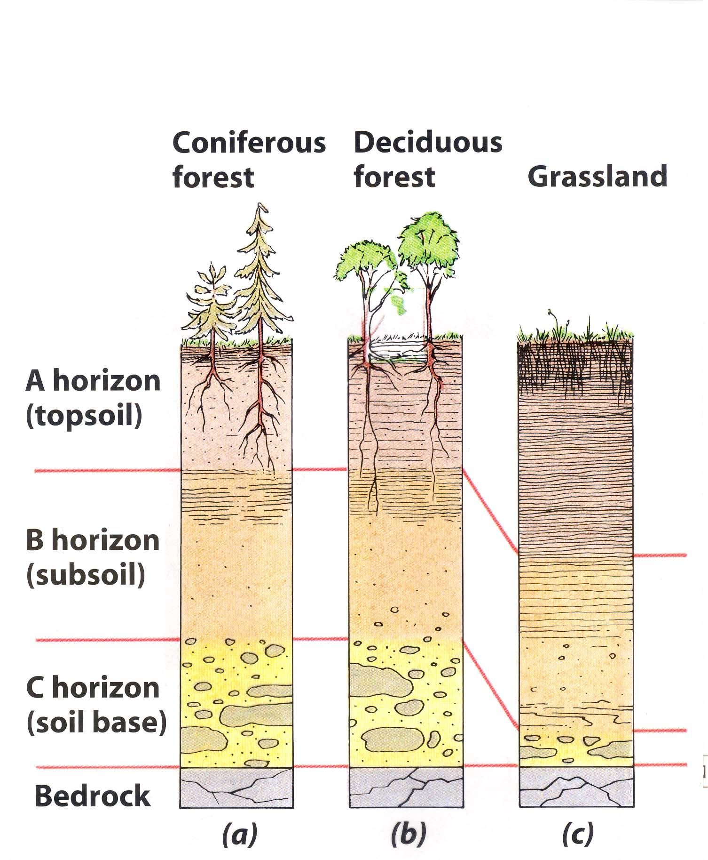

Nitrogen cycle

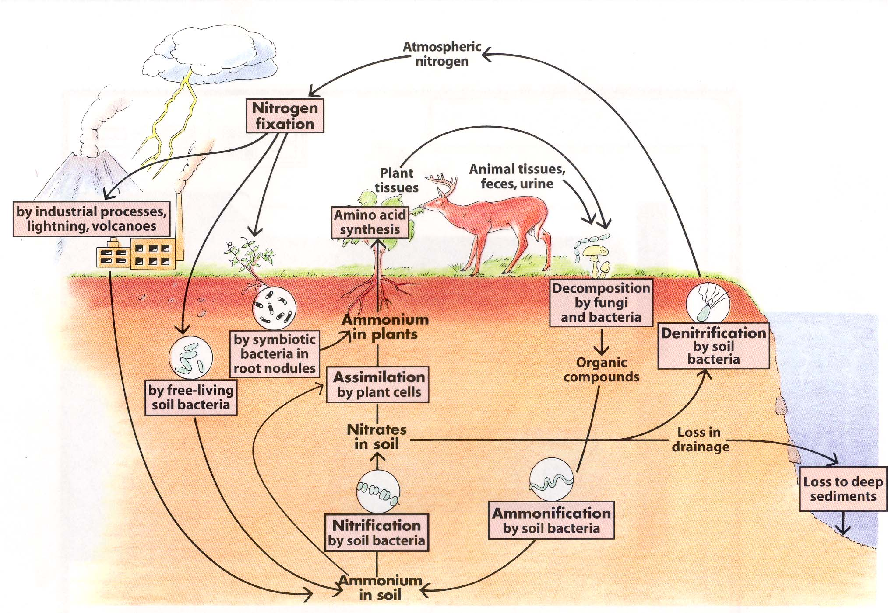

Rhizobium sp.
